**DAILY ONLINE ACTIVITIES SUMMARY**

|  |  |  |  |  |  |  |  |
| --- | --- | --- | --- | --- | --- | --- | --- |
| **Date:** | **19/05/2020** | | | | **Name:** | **Ambika V** | |
| **Sem & Sec** | **4th SEM 'A' Section** | | | | **USN:** | **4AL18CS005** | |
| **Online Test Summary** | | | | | | | |
| **Subject** | | **Design and Analysis of Algorithms** | | | | | |
| **Max. Marks** | | **30** | | **Score** | | **9** | |
| **Certification Course Summary** | | | | | | | |
| **Course** | **1Cloud foundation**  **2 workshop on python for beginners** | | | | | | |
| **Certificate Provider** | | | **greatlearning academy** | **Duration**  **Duration** | | | **1.5 hours**  **1.3 hours** |
| **Coding Challenges** | | | | | | | |
| **Problem Statement:** A user will input two strings, and we find if one of the strings is a sub sequence of the other. Program prints “yes” if either the first string is a sub sequence of the second string or the second string is a sub sequence of the first string. Assume that, the length of the first string is smaller than or equal to the length of the second string. Assume that, the length of the first string is smaller than or equal to the length of the second string. | | | | | | | |
| **Status: completed** | | | | | | | |
| **Uploaded the report in Github** | | | | **yes** | | | |
| **If yes Repository name** | | | | **https://github.com/ambika0202/lockdown-coding-** | | | |
| **Uploaded the report in slack** | | | | **yes** | | | |

ONLINE TEST DETAILS:

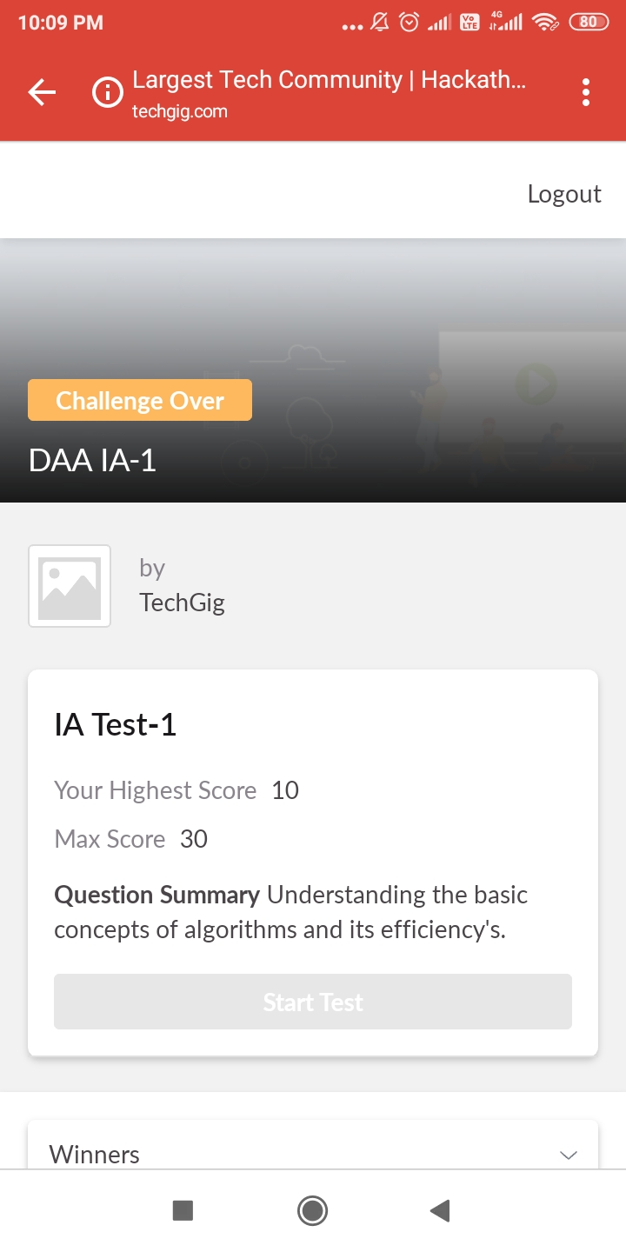

CERTIFICATION COURSE DETAILS:

* Cloud foundation: topics covered under cloud foundation are

1. History and evolution of cloud
2. The classical enterprise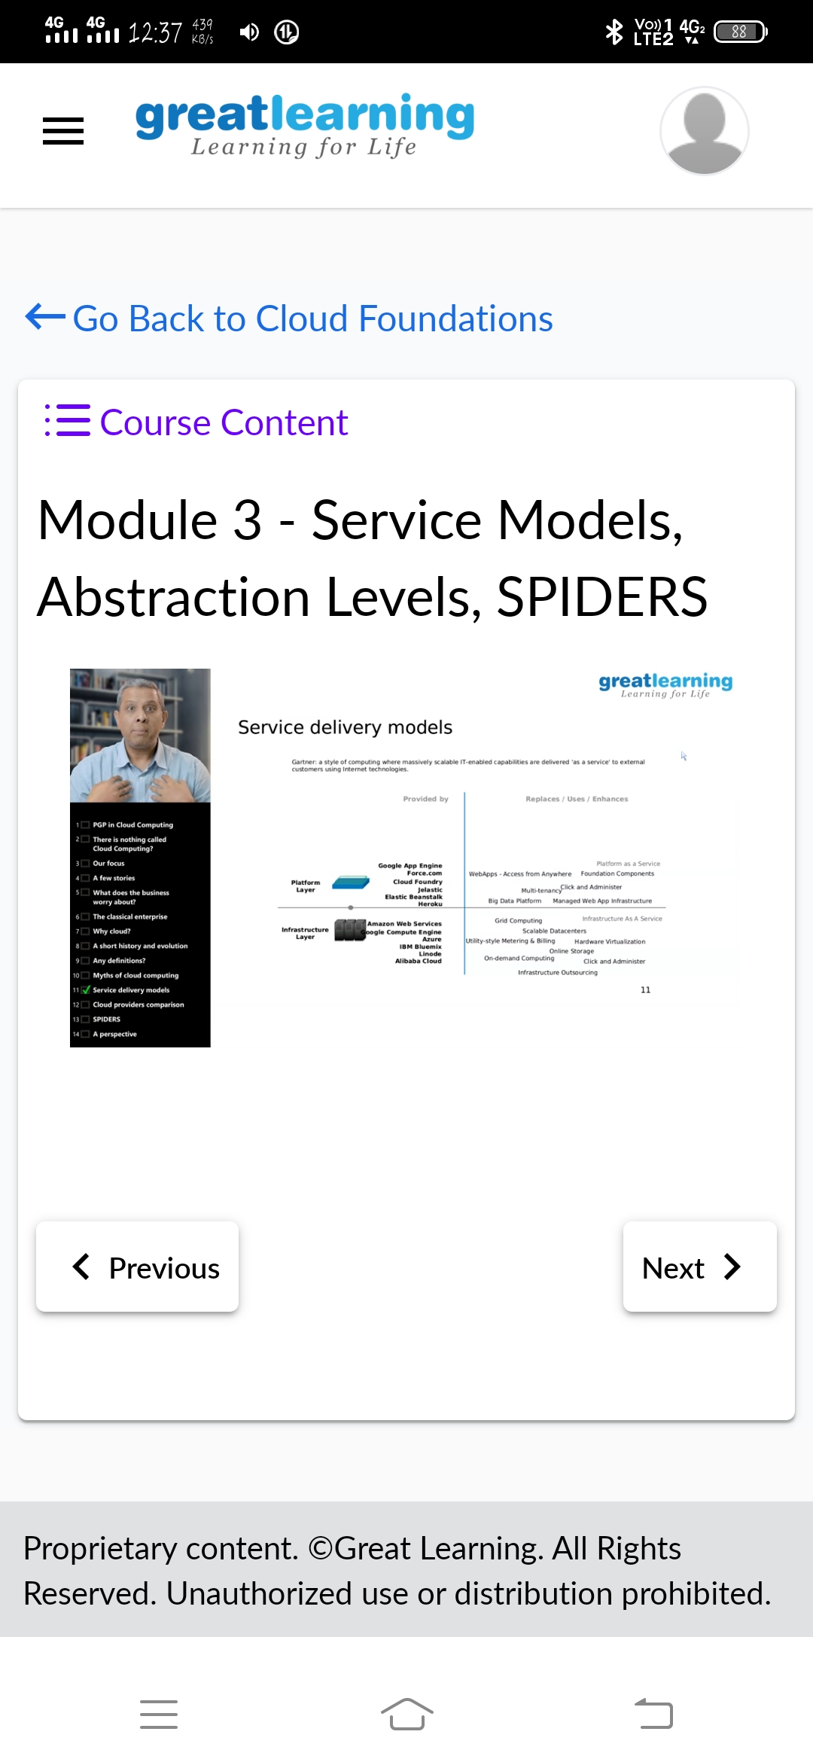
3. Myths of cloud computing
4. Service delivery models
5. Degree of abstraction
6. Cloud attributes
7. Service Offerings
8. Managed Services
9. Subscriptions
10. Cost economics
11. Elasticity
12. Virtualization

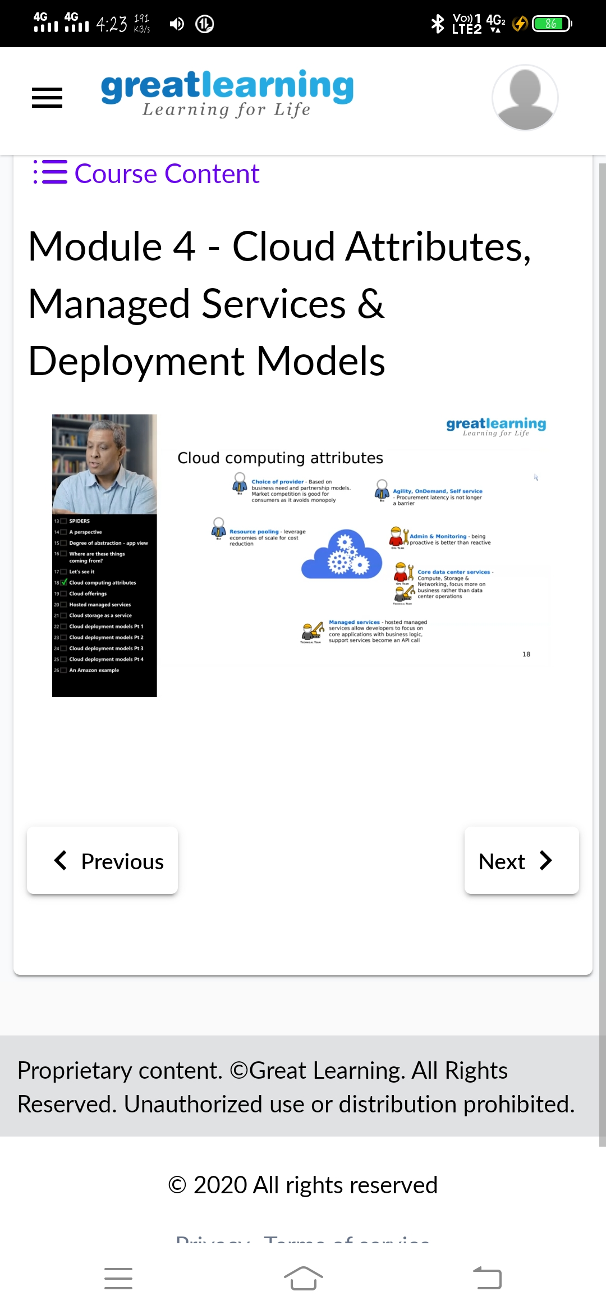

WORKSHOP ON PYTHON FOR BEGINNER

Goal of Event : Workshop Helps Candidate to Understand the Power of Python Language and Helps Them to Implement Any Real World Task

|  |  |  |  |  |
| --- | --- | --- | --- | --- |
| **Workshop Content for Python**    Basic Discussion on Subject :   * Whats Python and its scope in Present and Future * Why we need to go for Python   Internal Concept and Practical Implementation :   * Use Python Interpreter and Compiler * Basic Operations and Data Types * Go details in List, Tuple and Dictionary Usage * Code Block and Indentation * Conditions and Iteration * Built Own function and use built-in def * Manage and develop own modules * Manage Exception Handling * File Handling and Operations * Network Program and Socket Implementation   Overview Only :   * Overview of Class and Object Oriented Approach  |  |  | | --- | --- | |  |  | |  |  |

CODING CHALLENGES DETAILS:

Problem statement 1:

A user will input two strings, and we find if one of the strings is a sub sequence of the other. Program prints “yes” if either the first string is a sub sequence of the second string or the second string is a sub sequence of the first string.  
Assume that, the length of the first string is smaller than or equal to the length of the second string.

**An expected output of the program:**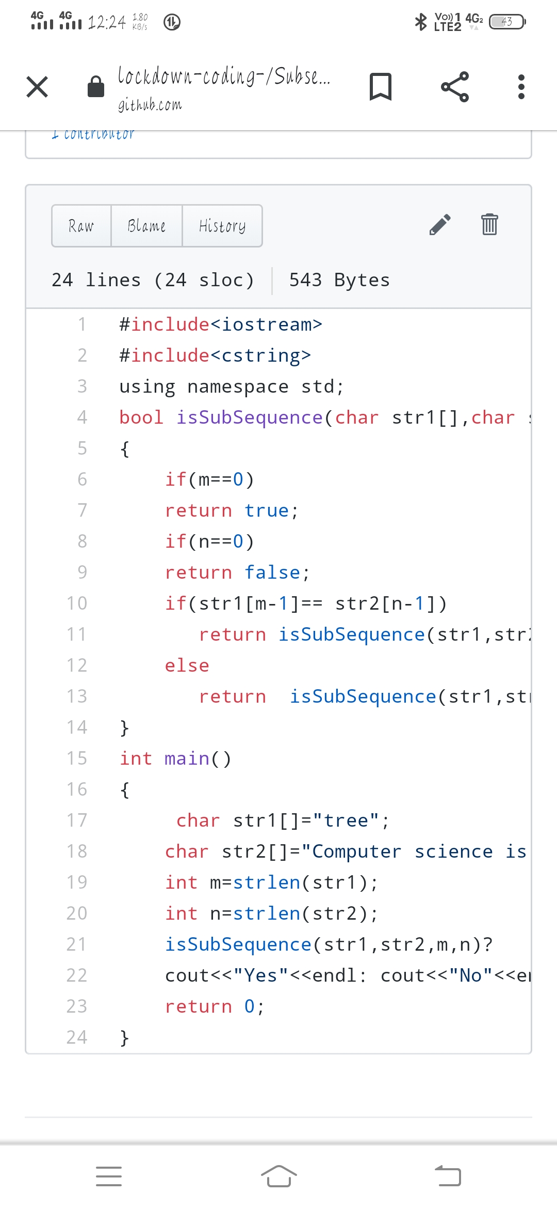

Input the first string  
tree  
Input the second string  
Computer science is awesome  
YES

Solution : Uploaded it in github

Problem statement 2:

We have a Letter or a word then we need add some letters to it and need to find out shortest palindrome  
For example we take "S": S will be the shortest palindrome string.  
If we take "xyz": zyxyz will be the shortest palindrome string  
So we need to add some characters to the given string or character and find out what will be the shortest palindrome string by using simple java program.

Solution: Uploaded in github.

